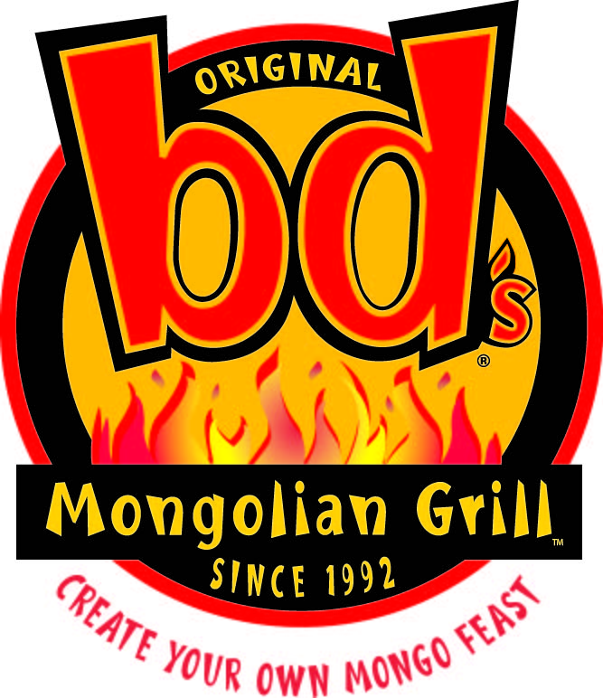 **Benefit Night Fundraiser**

**PAWS of Michigan**

**All Day 3/31/2016**

**EARN FREE $$$**

For your school, church, organization or club!

**How Benefit Nights Work…**

Just bring in this card on the date and time listed above and your organization will receive 15% of all sales generated by your members during the benefit.

**What bd’s Will Provide**

· A risk-free way to raise money

· You will receive the FREE $ your group earns promptly

**Your Part in a Successful Benefit Night**

· Spread the word – The more people that support your Benefit Night, the more FREE $$ your group earns!

· Remember the most important rule: Have Fun!

***ONLY AT:***

***Bd’s Dearborn***

***22115 Michigan Ave Dearborn MI***

***313-792-9660***

*This card cannot be distributed at the restaurant the night of the event.*

*Cannot be used with any other offer. Void where prohibited by law.*

** Benefit Night Fundraiser**

**PAWS of Michigan**

**All Day 3/31/2016**

**EARN FREE $$$**

For your school, church, organization or club!

**How Benefit Nights Work…**

Just bring in this card on the date and time listed above and your organization will receive 15% of all sales generated by your members during the benefit.

**What bd’s Will Provide**

· A risk-free way to raise money

· You will receive the FREE $ your group earns promptly

**Your Part in a Successful Benefit Night**

· Spread the word – The more people that support your Benefit Night, the more FREE $$ your group earns!

· Remember the most important rule: Have Fun!

***ONLY AT:***

***Bd’s Dearborn***

***22115 Michigan Ave Dearborn MI***

***313-792-9660***

*This card cannot be distributed at the restaurant the night of the event.*

*Cannot be used with any other offer. Void where prohibited by law.*

** Benefit Night Fundraiser**

**PAWS of Michigan**

**All Day 3/31/2016**

**EARN FREE $$$**

For your school, church, organization or club!

**How Benefit Nights Work…**

Just bring in this card on the date and time listed above and your organization will receive 15% of all sales generated by your members during the benefit.

**What bd’s Will Provide**

· A risk-free way to raise money

· You will receive the FREE $ your group earns promptly

**Your Part in a Successful Benefit Night**

· Spread the word – The more people that support your Benefit Night, the more FREE $$ your group earns!

· Remember the most important rule: Have Fun!

***ONLY AT:***

***Bd’s Dearborn***

***22115 Michigan Ave Dearborn MI***

***313-792-9660***

*This card cannot be distributed at the restaurant the night of the event.*

*Cannot be used with any other offer. Void where prohibited by law.*

**Benefit Night Fundraiser**

**Nowlin Elementary**

**February 7, 2013**

**EARN FREE $$$**

For your school, church, organization or club!

**How Benefit Nights Work…**

Just bring in this card on the date and time listed above and your organization will receive 15% of all sales generated by your members during the benefit.

**What bd’s Will Provide**

· A risk-free way to raise money

· We’ll advertise you event on our marquee sign.

· You will receive the FREE $ your group earns promptly

**Your Part in a Successful Benefit Night**

· Spread the word – The more people that support your Benefit Night, the more FREE $$ your group earns!

· Remember the most important rule: Have Fun!

***ONLY AT:***

***Bd’s Dearborn***

***22115 Michigan Ave Dearborn MI***

***313-792-9660***

*This card cannon be distributed at the restaurant the night of the event.*

*Cannot be used with any other offer. Void where prohibited by law.*

*© 2007 Burger King Brands Inc. All Rights Reserved*

** Benefit Night Fundraiser**

**PAWS of Michigan**

**All Day 3/31/2016**

**EARN FREE $$$**

For your school, church, organization or club!

**How Benefit Nights Work…**

Just bring in this card on the date and time listed above and your organization will receive 15% of all sales generated by your members during the benefit.

**What bd’s Will Provide**

· A risk-free way to raise money

· You will receive the FREE $ your group earns promptly

**Your Part in a Successful Benefit Night**

· Spread the word – The more people that support your Benefit Night, the more FREE $$ your group earns!

· Remember the most important rule: Have Fun!

***ONLY AT:***

***Bd’s Dearborn***

***22115 Michigan Ave Dearborn MI***

***313-792-9660***

*This card cannot be distributed at the restaurant the night of the event.*

*Cannot be used with any other offer. Void where prohibited by law.*

**Benefit Night Fundraiser**

**Nowlin Elementary**

**February 7, 2013**

**EARN FREE $$$**

For your school, church, organization or club!

**How Benefit Nights Work…**

Just bring in this card on the date and time listed above and your organization will receive 15% of all sales generated by your members during the benefit.

**What bd’s Will Provide**

· A risk-free way to raise money

· We’ll advertise you event on our marquee sign.

· You will receive the FREE $ your group earns promptly

**Your Part in a Successful Benefit Night**

· Spread the word – The more people that support your Benefit Night, the more FREE $$ your group earns!

· Remember the most important rule: Have Fun!

***ONLY AT:***

***Bd’s Dearborn***

***22115 Michigan Ave Dearborn MI***

***313-792-9660***

*This card cannon be distributed at the restaurant the night of the event.*

*Cannot be used with any other offer. Void where prohibited by law.*

*© 2007 Burger King Brands Inc. All Rights Reserved*

** Benefit Night Fundraiser**

**PAWS of Michigan**

**All Day 3/31/2016**

**EARN FREE $$$**

For your school, church, organization or club!

**How Benefit Nights Work…**

Just bring in this card on the date and time listed above and your organization will receive 15% of all sales generated by your members during the benefit.

**What bd’s Will Provide**

· A risk-free way to raise money

· You will receive the FREE $ your group earns promptly

**Your Part in a Successful Benefit Night**

· Spread the word – The more people that support your Benefit Night, the more FREE $$ your group earns!

· Remember the most important rule: Have Fun!

***ONLY AT:***

***Bd’s Dearborn***

***22115 Michigan Ave Dearborn MI***

***313-792-9660***

*This card cannot be distributed at the restaurant the night of the event.*

*Cannot be used with any other offer. Void where prohibited by law.*

**Benefit Night Fundraiser**

**Nowlin Elementary**

**February 7, 2013**

**EARN FREE $$$**

For your school, church, organization or club!

**How Benefit Nights Work…**

Just bring in this card on the date and time listed above and your organization will receive 15% of all sales generated by your members during the benefit.

**What bd’s Will Provide**

· A risk-free way to raise money

· We’ll advertise you event on our marquee sign.

· You will receive the FREE $ your group earns promptly

**Your Part in a Successful Benefit Night**

· Spread the word – The more people that support your Benefit Night, the more FREE $$ your group earns!

· Remember the most important rule: Have Fun!

***ONLY AT:***

***Bd’s Dearborn***

***22115 Michigan Ave Dearborn MI***

***313-792-9660***

*This card cannon be distributed at the restaurant the night of the event.*

*Cannot be used with any other offer. Void where prohibited by law.*

*© 2007 Burger King Brands Inc. All Rights Reserved*

** Benefit Night Fundraiser**

**PAWS of Michigan**

**All Day 3/31/2016**

**EARN FREE $$$**

For your school, church, organization or club!

**How Benefit Nights Work…**

Just bring in this card on the date and time listed above and your organization will receive 15% of all sales generated by your members during the benefit.

**What bd’s Will Provide**

· A risk-free way to raise money

· You will receive the FREE $ your group earns promptly

**Your Part in a Successful Benefit Night**

· Spread the word – The more people that support your Benefit Night, the more FREE $$ your group earns!

· Remember the most important rule: Have Fun!

***ONLY AT:***

***Bd’s Dearborn***

***22115 Michigan Ave Dearborn MI***

***313-792-9660***

*This card cannot be distributed at the restaurant the night of the event.*

*Cannot be used with any other offer. Void where prohibited by law.*

**Benefit Night Fundraiser**

**Nowlin Elementary**

**February 7, 2013**

**EARN FREE $$$**

For your school, church, organization or club!

**How Benefit Nights Work…**

Just bring in this card on the date and time listed above and your organization will receive 15% of all sales generated by your members during the benefit.

**What bd’s Will Provide**

· A risk-free way to raise money

· We’ll advertise you event on our marquee sign.

· You will receive the FREE $ your group earns promptly

**Your Part in a Successful Benefit Night**

· Spread the word – The more people that support your Benefit Night, the more FREE $$ your group earns!

· Remember the most important rule: Have Fun!

***ONLY AT:***

***Bd’s Dearborn***

***22115 Michigan Ave Dearborn MI***

***313-792-9660***

*This card cannon be distributed at the restaurant the night of the event.*

*Cannot be used with any other offer. Void where prohibited by law.*

*© 2007 Burger King Brands Inc. All Rights Reserved*